|  |  |  |
| --- | --- | --- |
| **SPRINT – 1**  **WORKING WITH THE DATASET(UNDERSTANDING THE DATASET)** | | |
|  | Date | 18 November 2022 |
| Team ID | PNT2022TMID20305 |
| Project Name | Estimate The Crop Yield Using Data Analytics |
| “Estimate The Crop Yield Using Data Analytics” project is based on understanding the crop production of India.Download the dataset from the below link. It has 2,46,092 data points (rows) and 6 features (columns) describing each crop production related details.  **Dataset Link** : [Dataset](https://www.kaggle.com/abhinand05/crop-production-in-india)  Let’s understand the data we’re working with and give a brief overview of what each feature represents or should represent   1. State Name - All the Indian State names. 2. District Name - Different District names. 3. Crop Year- contains the crop years. 4. Season - Different seasons for crop production. 5. Area - Total number of areas covered. 6. Production - production of crops. | | |

**UNDERSTAND THE DATASET:**

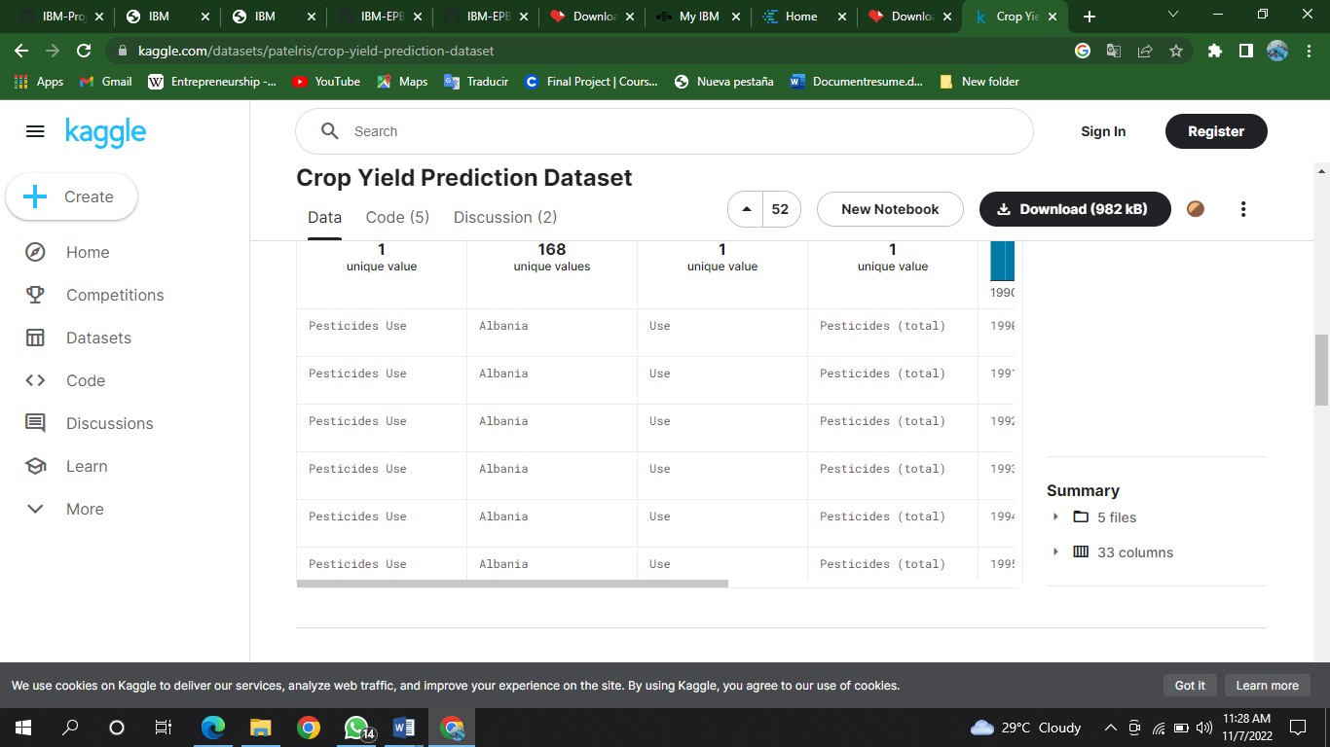

* Download the dataset from the given dataset link.
* Data Given in csv file is understood.
* The data format is as shown in the below image:

